Papers written by Australian Maths Software

SEMESTER TWO

MATHEMATICS SPECIALIST
REVISION 3
UNIT 3-4

2016

SOLUTIONS

Section One
1. (3 marks)
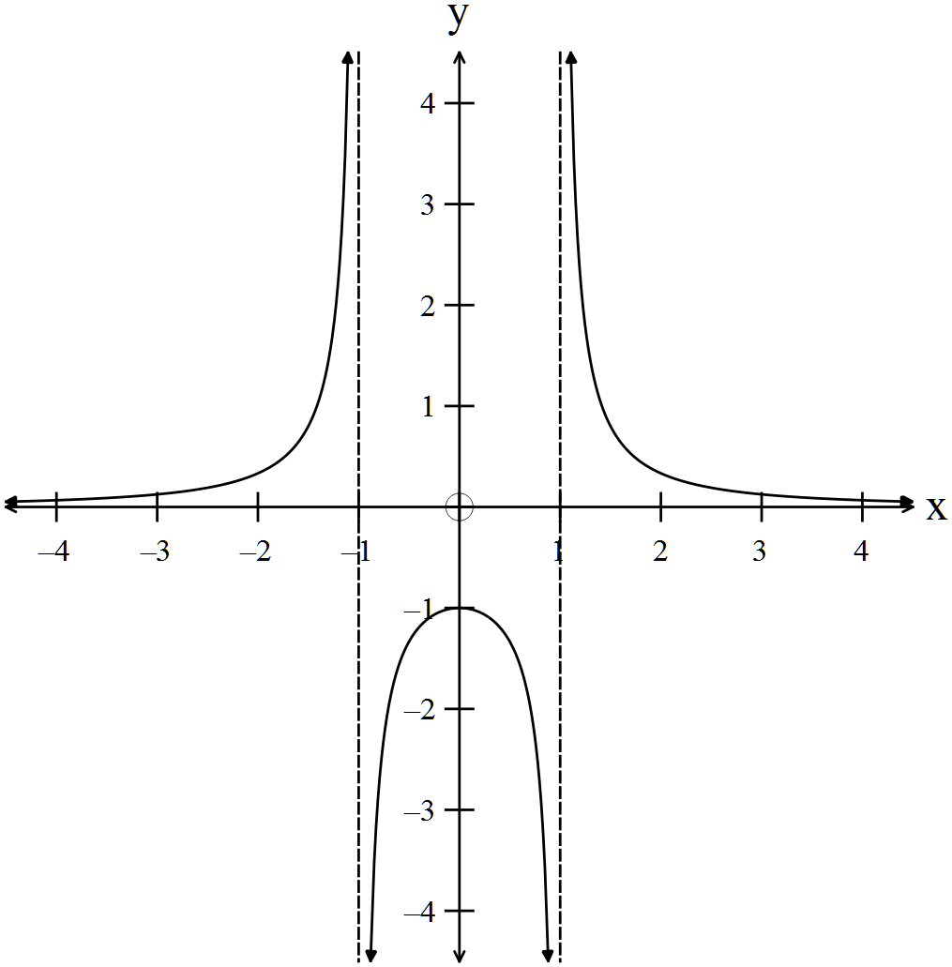
✓

✓

✓

2. (5 marks)
(a) 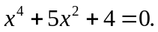
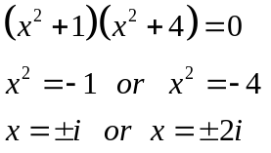
✓

✓

✓

(b) 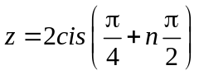
✓

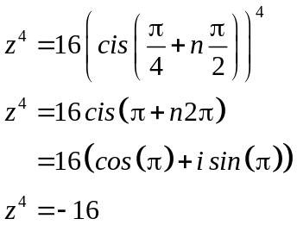
✓

3. (7 marks)
(a) 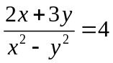
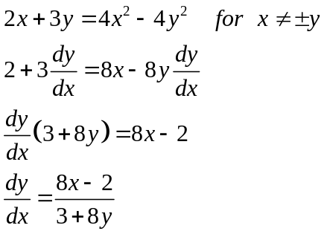
✓

✓✓

✓

(b) 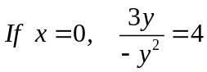
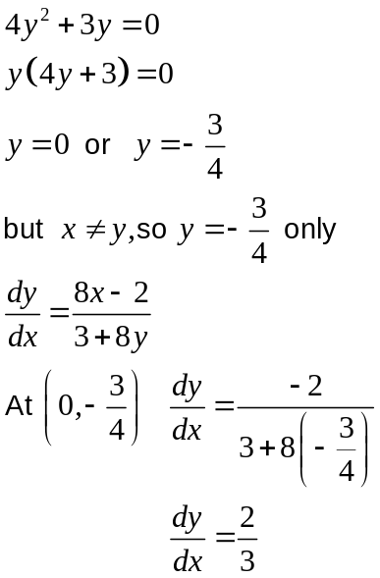
✓

✓

✓

4 (9 marks)
(a) 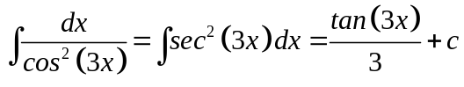
✓✓

(b) 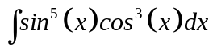
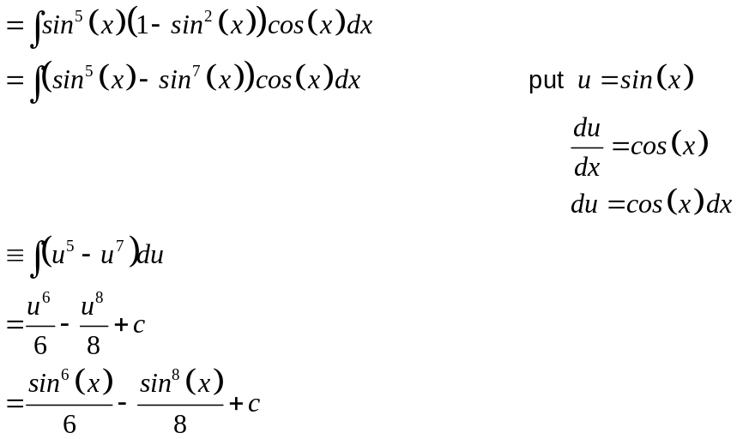
✓

✓

✓

✓

(c) 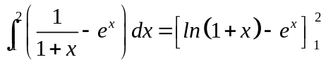
✓

✓

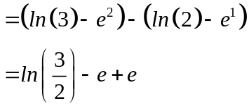
✓

5. (5 marks)

(a) 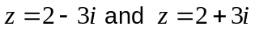
✓

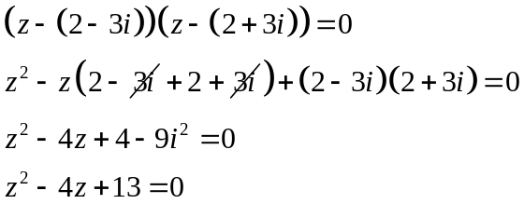
✓

(b) 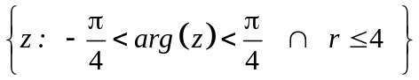 ✓✓✓

6. (10 marks)
(a) 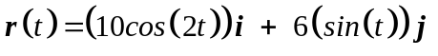
✓

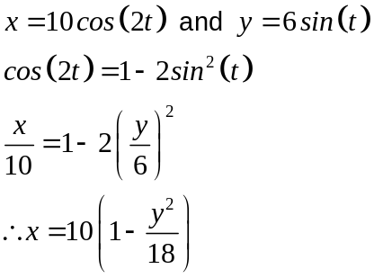
✓

✓

which is parabolic

(b) At end points when 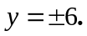
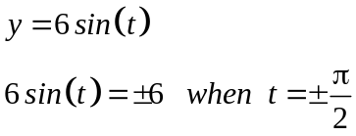
✓✓

(c) 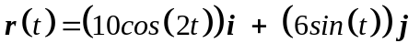
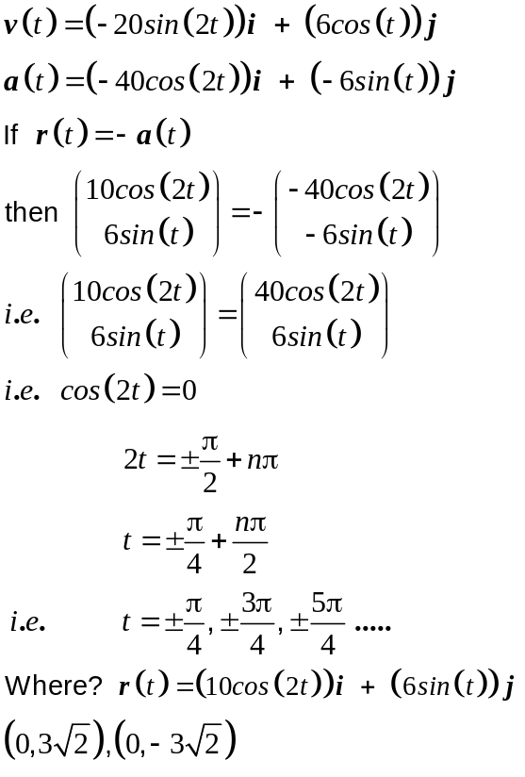
✓
✓
✓
✓
✓

7. (5 marks)
Since one of the direction vectors of the plane is the same as the direction vetor
of the line, the line is either parallel ti the plane or contained IN the plane. ✓
Need to determine if the point P(2, 0, 1) belongs to the plane.

Plane:
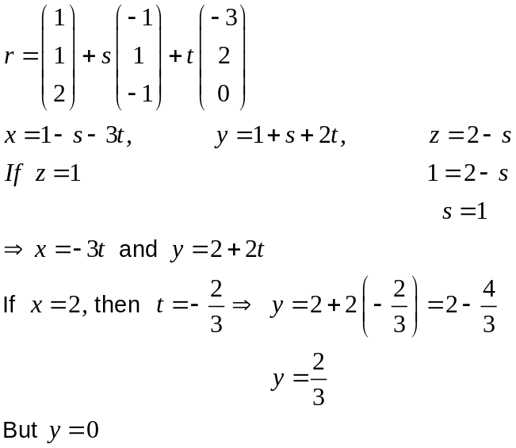
✓
✓
✓
Therefore the point does NOT belong to the plane.
✓
Therefore the line is parallel to the plane.

8. (3 marks)
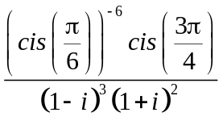
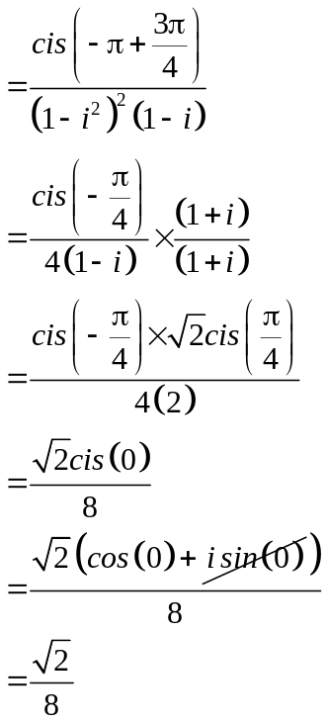
✓

✓

✓

9. (6 marks)

(a)
✓✓ -1/error

x | -2 | -1 | 0 | 1 | 2
y | 1 | 1 | 1 | 1 | 1
 | 4 | 2 | 0 | -2 | -4

(b)
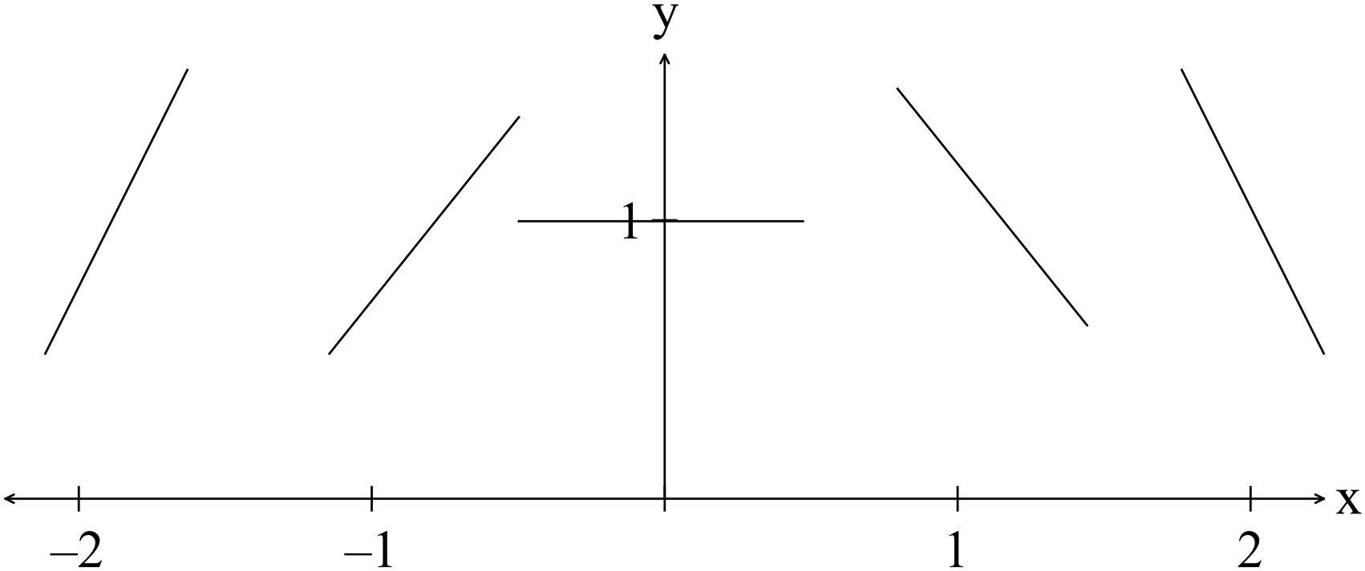
✓✓ -1/error

(c) 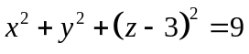 is a sphere with centre (0, 0, 3) and radius 3.
✓
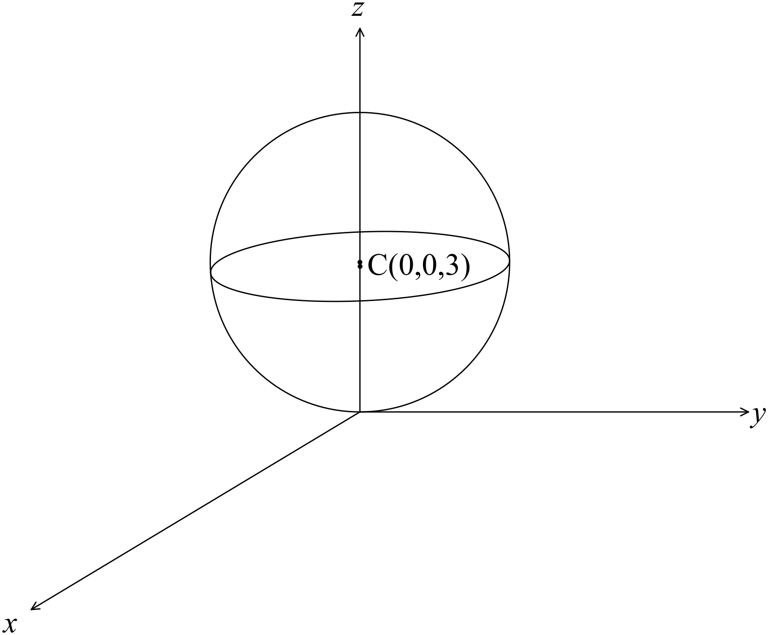
✓

END OF SECTION ONE
Section Two
10. (5 marks)
(a) Path of insect: 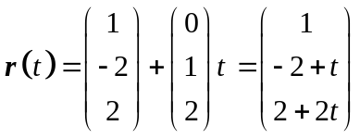
✓

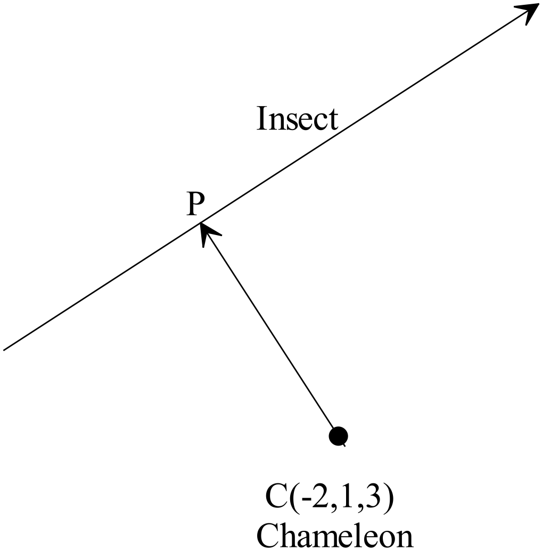
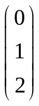

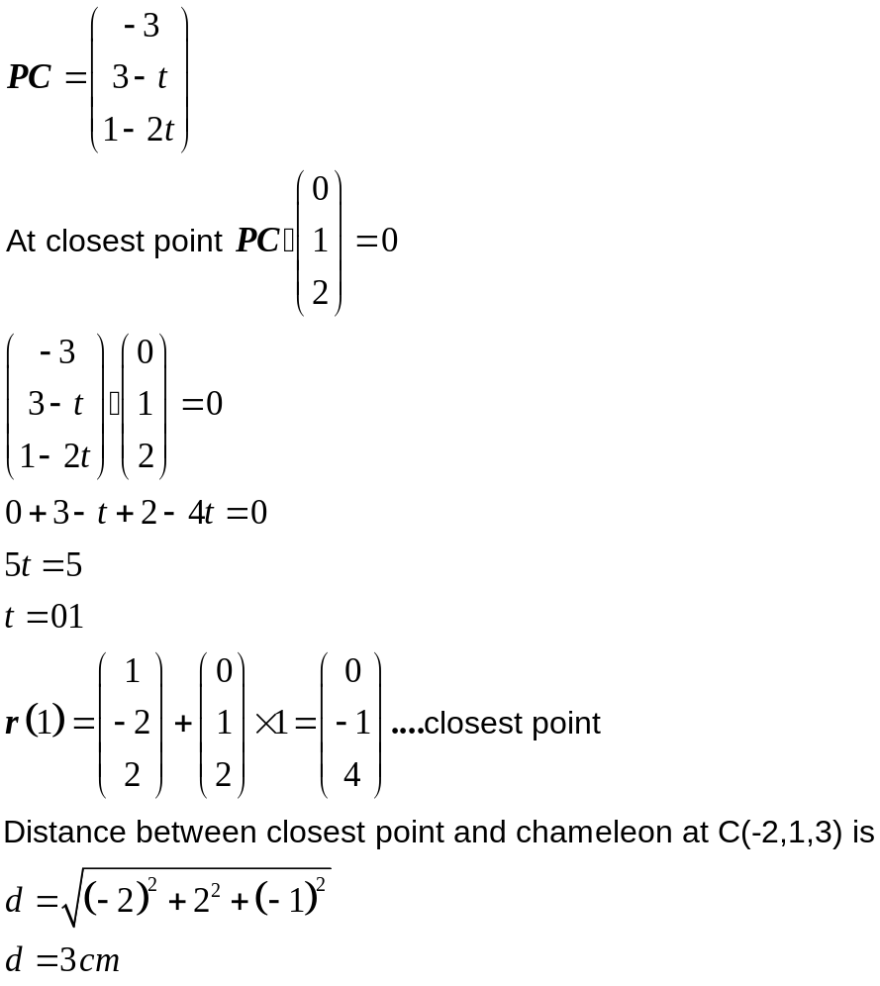
✓
✓
✓
The insect will be dinner!!!

(b) The set of points represent a sphere of centre (1, -2, 0) and radius 3. ✓
11. (8 marks)
Given 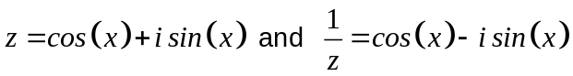
(a) (i) 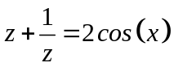
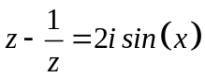 ✓
(ii) 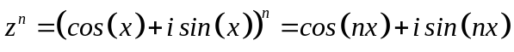 ✓
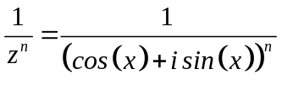
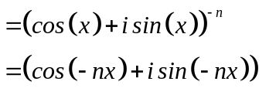
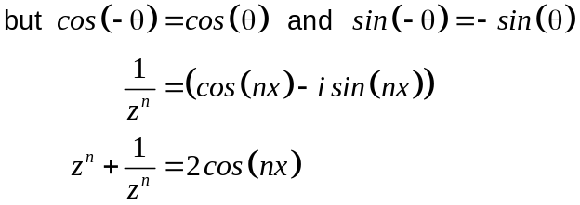
✓
✓

(iii) 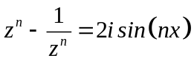 ✓

(b) Show that
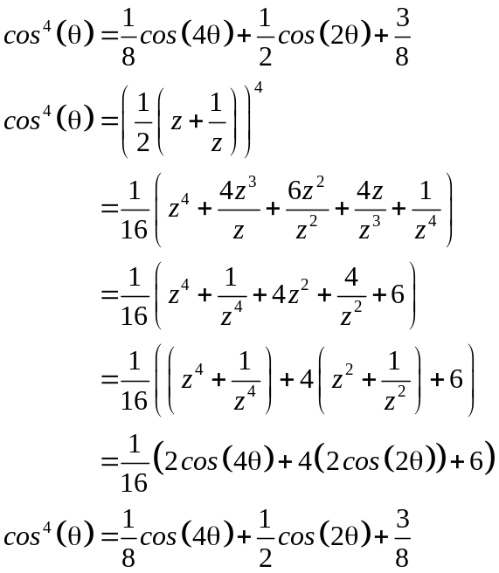
✓
✓
✓
12. (12 marks)
(a) (i) 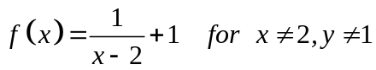 ✓✓
(ii) To obtain the inverse swap x and y
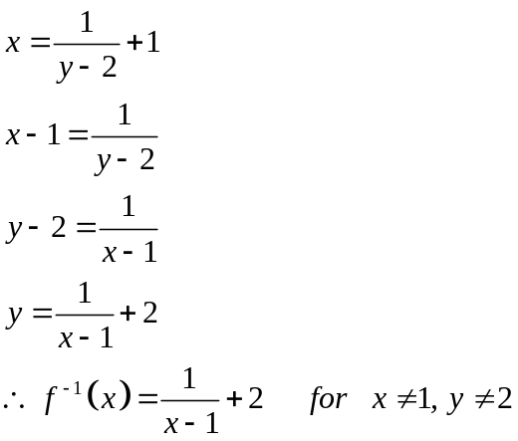
✓ ✓ ✓

(b) (i) 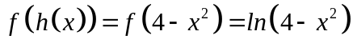 ✓
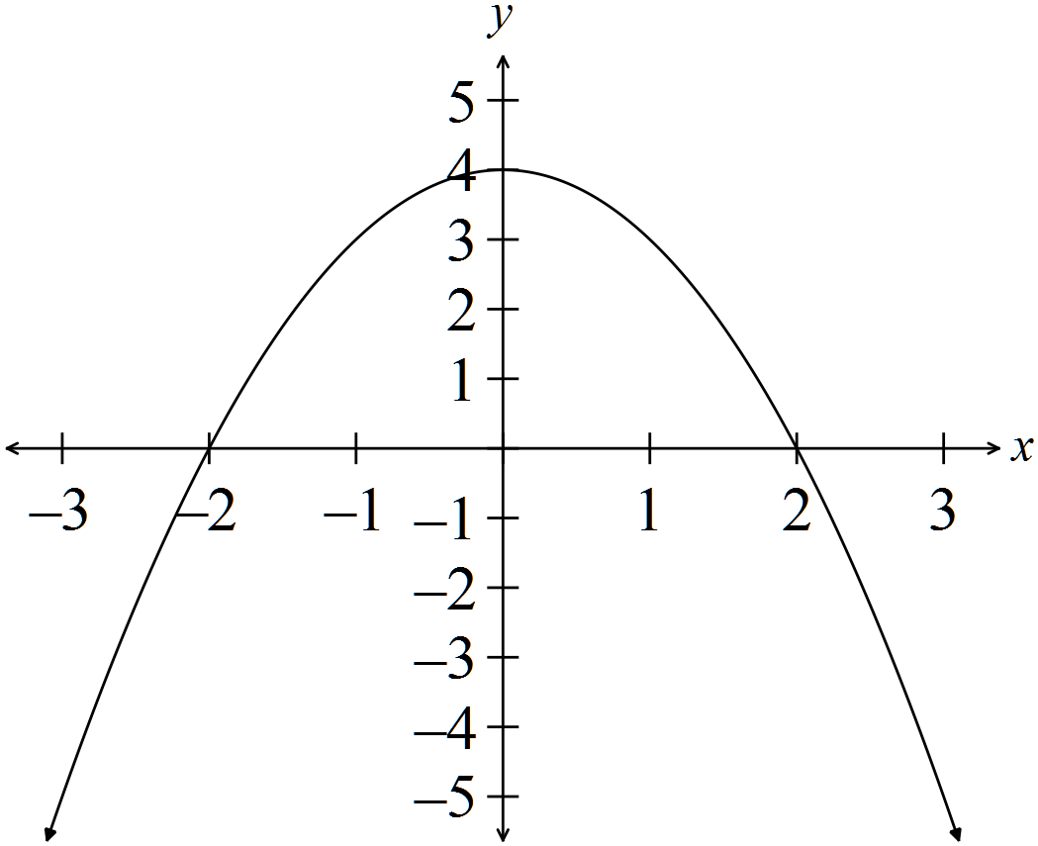
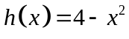
The domain is 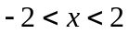 and the range is 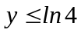
✓ ✓
(ii) 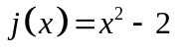
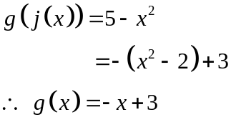
✓
✓

(iii) 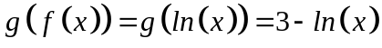

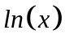 is a one to one function so 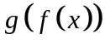 is also a one to one function.
✓
✓
13. (6 marks)
(a) 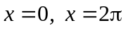 ✓✓✓
(b) Area = 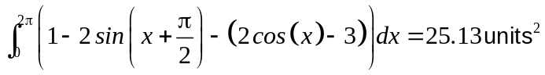 ✓✓✓
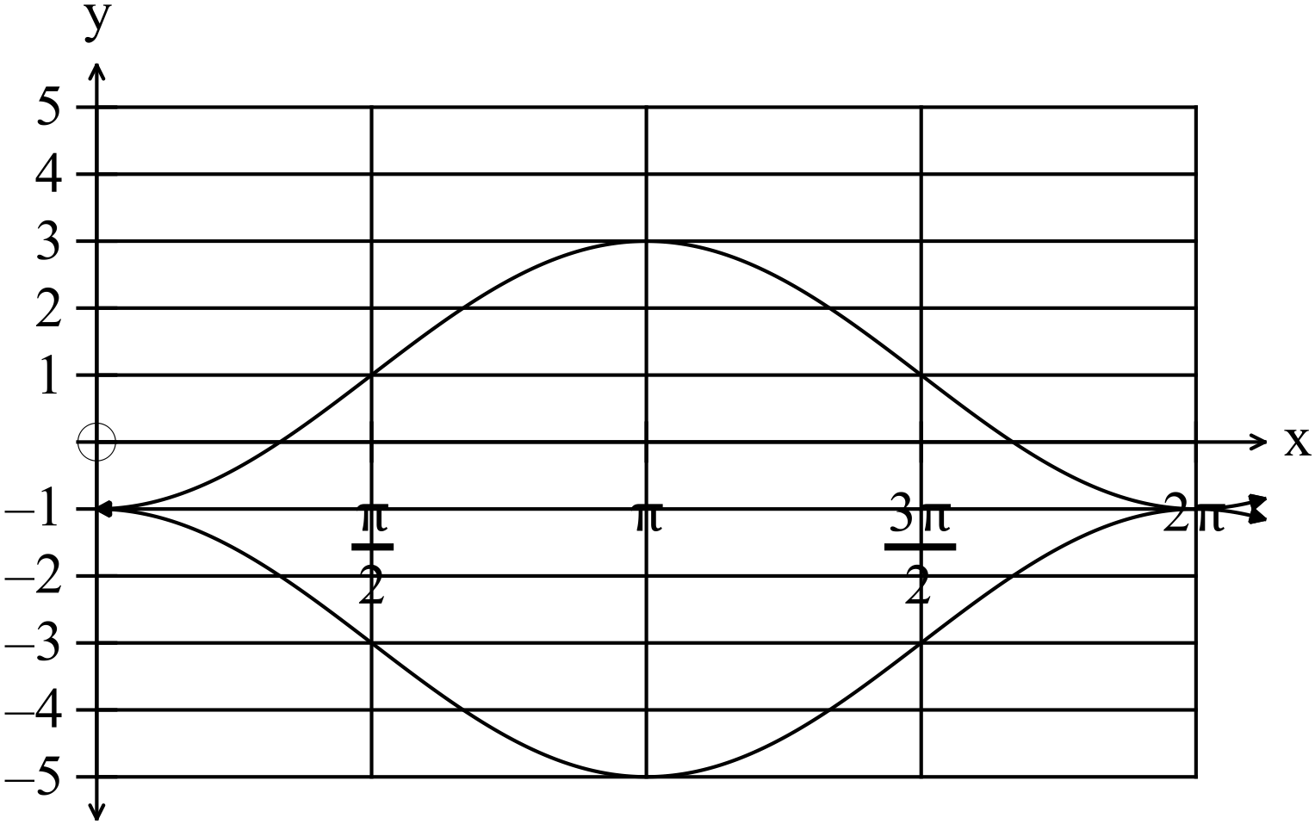

14. (7 marks)
(a) 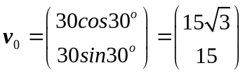
✓

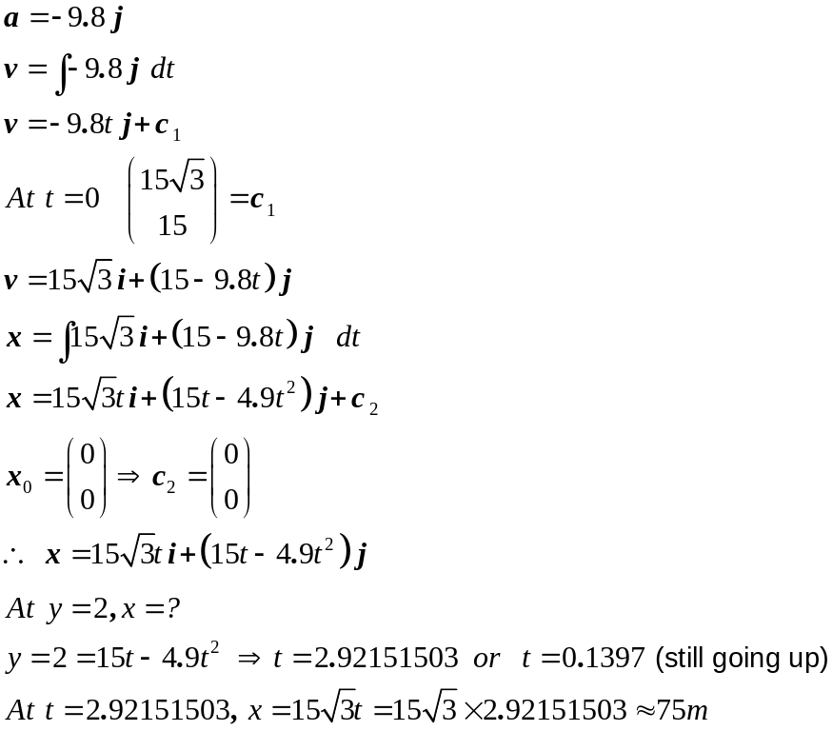
✓
✓
✓
✓
✓
Yes, the arrow goes over the back fence.

(b) 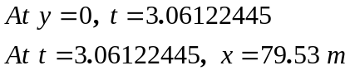
✓

15. (10 marks)
(a) 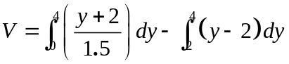
✓ ✓ ✓ ✓

(b) (i) The period is 2 cm. ✓ 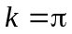 ✓
(ii) 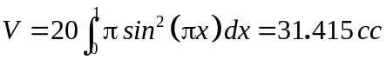
✓ ✓ ✓ ✓

16. (14 marks)
(a) 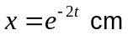
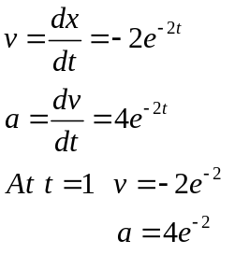
✓
✓
✓

(b) (i) 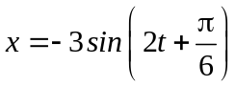
SHM if 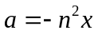
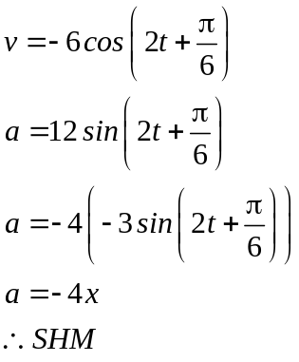
✓
✓
✓

(ii) 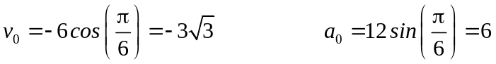
✓
✓

(iii) 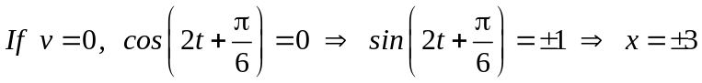 ✓

(c) 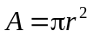
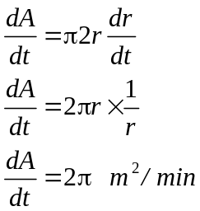
✓
✓
which is constant

(d) 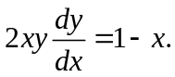
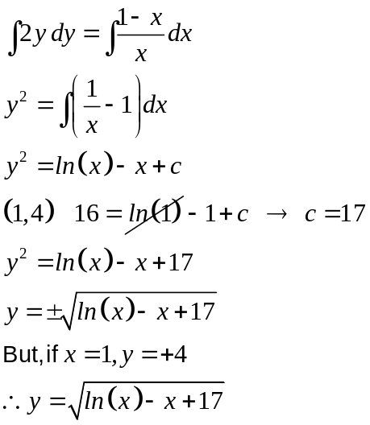
✓
✓
✓

17. (8 marks)
(a) Let equation of the plane be 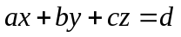
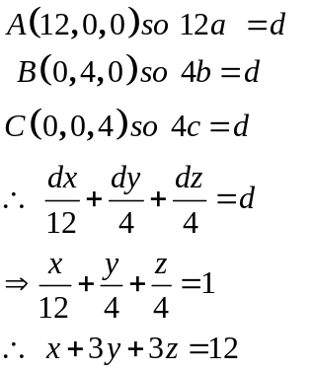
✓
✓
✓

(b) 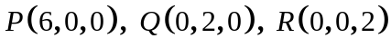
Likewise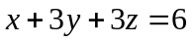
The planes are parallel as the coefficients of x, y, and z are all identical. ✓
NB (a) and (b) can be done using vectors.
(c) 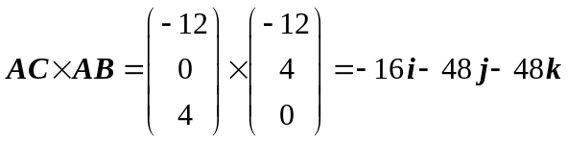 ✓✓
(d) 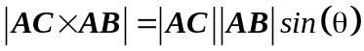
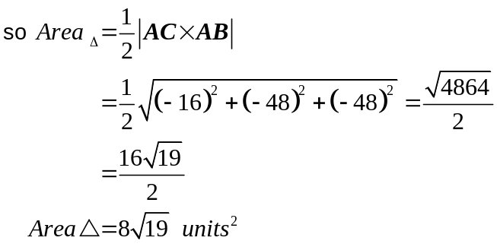
✓
✓

18. (8 marks)
✓
(a) (i) 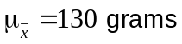
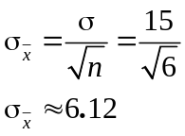
✓
✓

(ii) When a sample is taken, the range is usually smaller as it does not
usually contain any outliers (which are rare scores).
Most apples would be close to the mean weight, and it is unlikely to select
an unusually big or small apple in a small sample, so a sample
of 6 would have a small standard deviation.
✓✓

✓
(b) The average time they would wait is is 20 minutes.
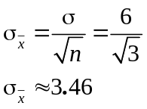
✓
✓
19. (7 marks)
✓
(a) The expected mean is 160 cm.
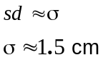
✓
✓
(b) 95% confidence limits 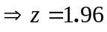
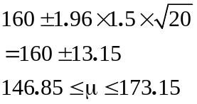
✓
✓

(c) To be 90% sure the confidence limits are correct, you can have a smaller ranger as there is a 10% error margin.
To be surer, i.e. a 95% confidence limit then you have a wider range so there is
✓✓

a bigger chance that the mean will be included.

20. (13 marks)

(a) (i) 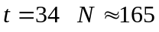 ✓
(ii) 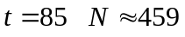 ✓
(b) 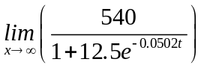
✓
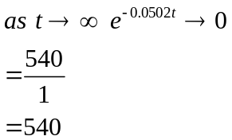
✓

(c) 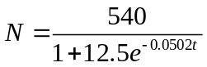
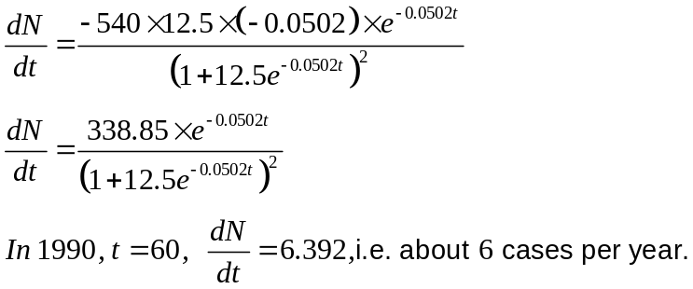
✓
✓
✓
✓

(d) 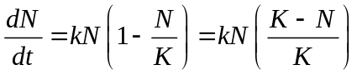
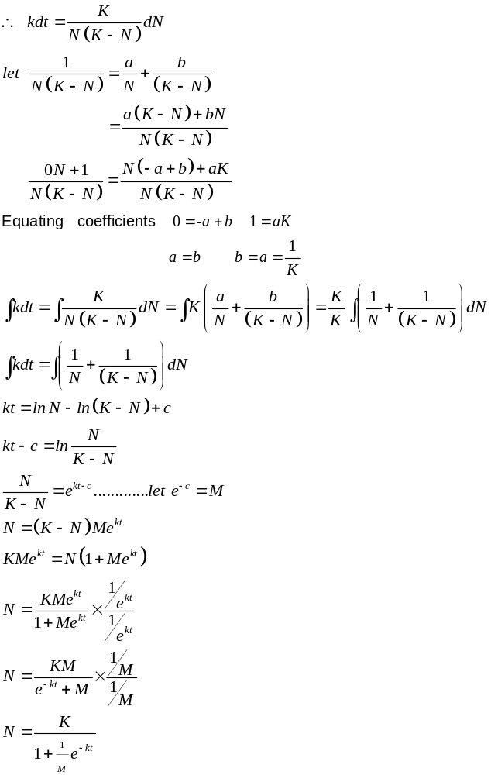
✓
✓
✓
✓
✓

END OF SECTION TWO
✓

